Project description
ABOUT THE PROJECT:
in this project I am going to build a Temperature Controlled Fan using LM35 precision Temperature sensor. we can get the Temperature value on and Fan speed on HD44780(16 * 2) LCD. Let's get started!
NECESSITY OF THE PROJECT:
Almost in summer days sometimes days become extremely hot and sometimes extremely Cold. so we use a Fan Regulator to regulate the speed of Fan according to the environment Temperature i.e. if temperature is High, we rotate the knob of the potentiometer in clockwise direction but anticlockwise in case of low Temperature. But we are living in 2021. This is the time of Microcontrollers( like Arduino development boards). and people like to use an automatic Temperature controlled Fan ( A Fan that rotates according to temperature).So that is why in this project I am going to make a Temperature Controlled Fan. Although in this project I am using a 12V DC Fan in place of 230V/50Hz AC Fan. But I make a promise that I will really make next project on AC Fan.
HARDWARE LIST:
- Arduino nano
- HD44780 LCD (16 * 2) lcd
- LM35 Temperature Sensor
- 12V CPU Fan
- IRLZ44 N-Channel MOSFET
- LM7805 Regulator
- BC547 Transistor
- Buzzer
- Bread board
- jumper wires
- 1k Resistors
- 100UF/25V electrolytic capacitor
- 1N4007 Diode
- 10K Potentiometer
- 12V Battery
ABOUT LM35 SENSOR:
The LM 35 series are precision integrated-circuit Temperature sensor with an output voltage linearly proportional to Centigrade Temperature.This sensor looks like a Transistor because and it is available in TO-92 Package/TO-220 Package/TO-46 metal can package/SO-8 package. but In present I am going to use TO-92 package. The pinout of the IC has been given below-
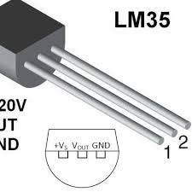
Features of LM35 Sensor-
- Calibrated directly in Celsius
- linear +10mV/deg.C scale factor
- -55/deg.C to +150/deg.C range
- operation Voltage 4 - 30V
for more you can visit
﻿$ https://www.electroschematics.com/wp-content/uploads/2010/02/LM35-DATASHEET.pdf $ ﻿
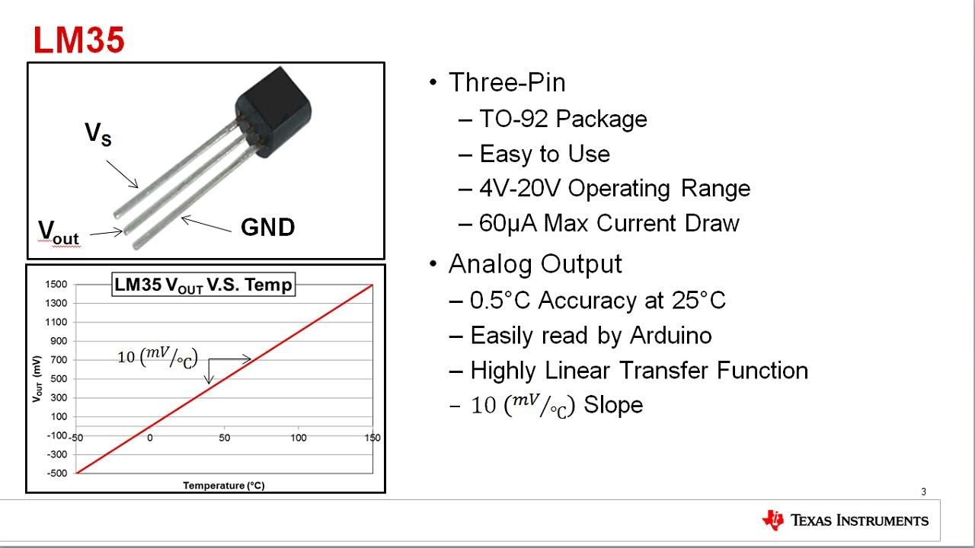
LIBRARY FOR LM35 SENSOR:
﻿$ https://www.arduino.cc/reference/en/libraries/lm35-sensor/ $ ﻿
FOLLOW THESE STEPS TO MAKE THE PROJECT:
connect all the necessary parts to one another according to given schematic then check all the connections twice because if the is any error in the connections that you make, your project will not work and the write the codes for the project if you don't know how to do that then you can just copy my code and paste it on your editor and upload, after uploading supply the project with a 12V Lead-Acid Battery
PICTURES OF MY WORK:
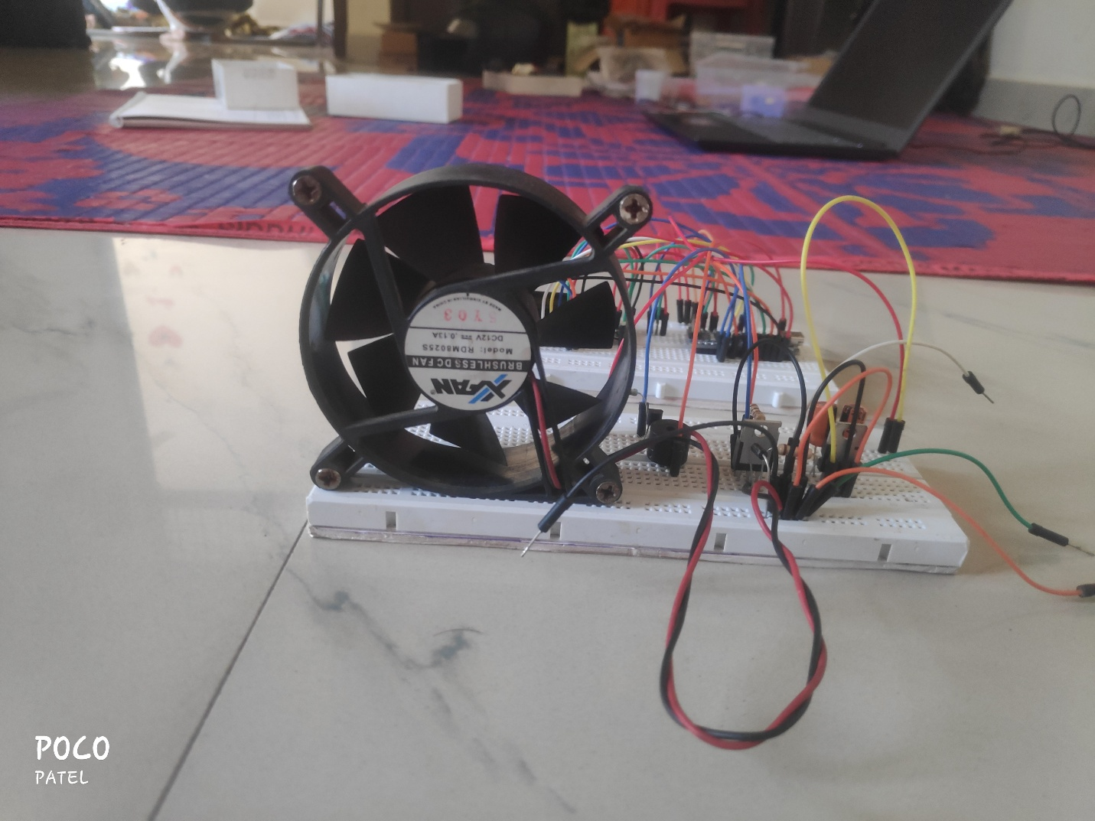
PICTURE-1
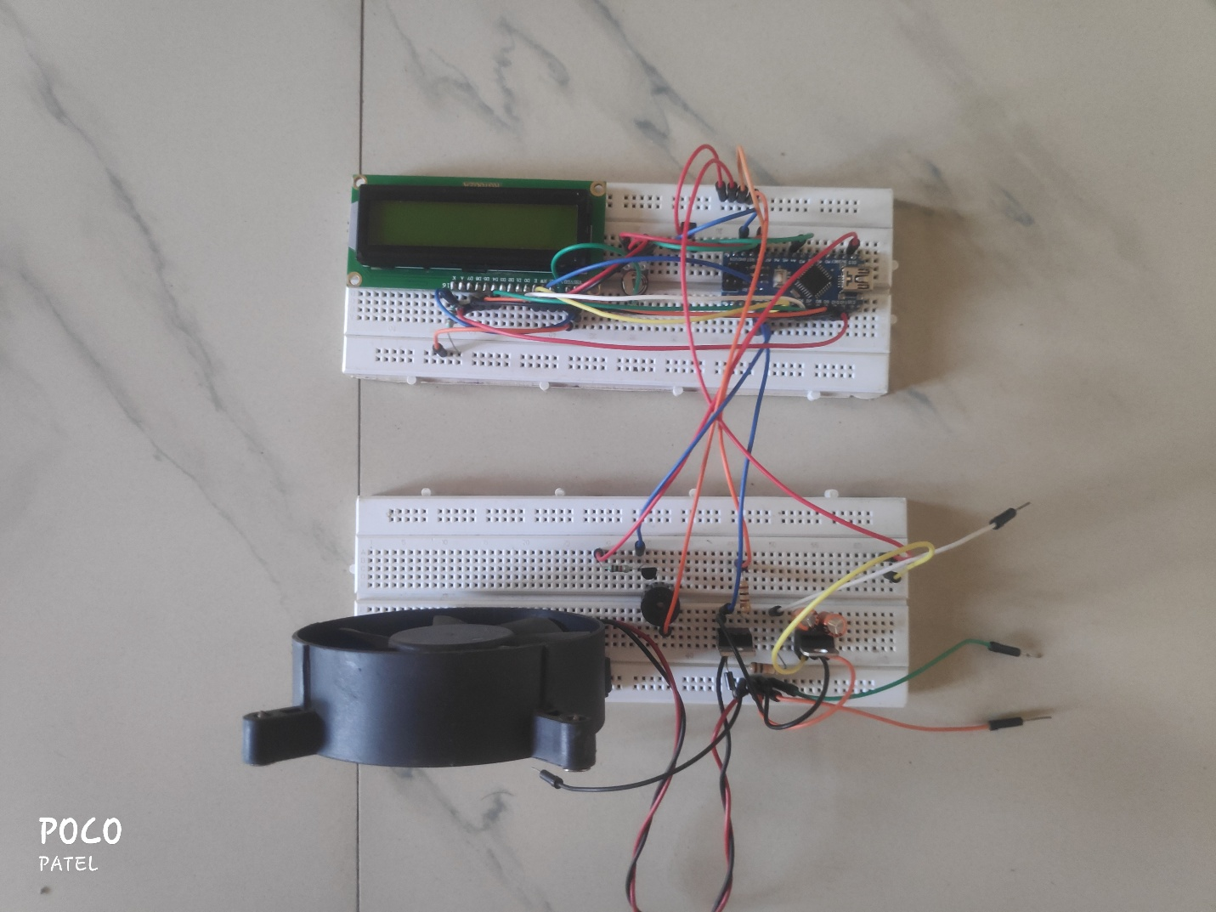
Picture-2
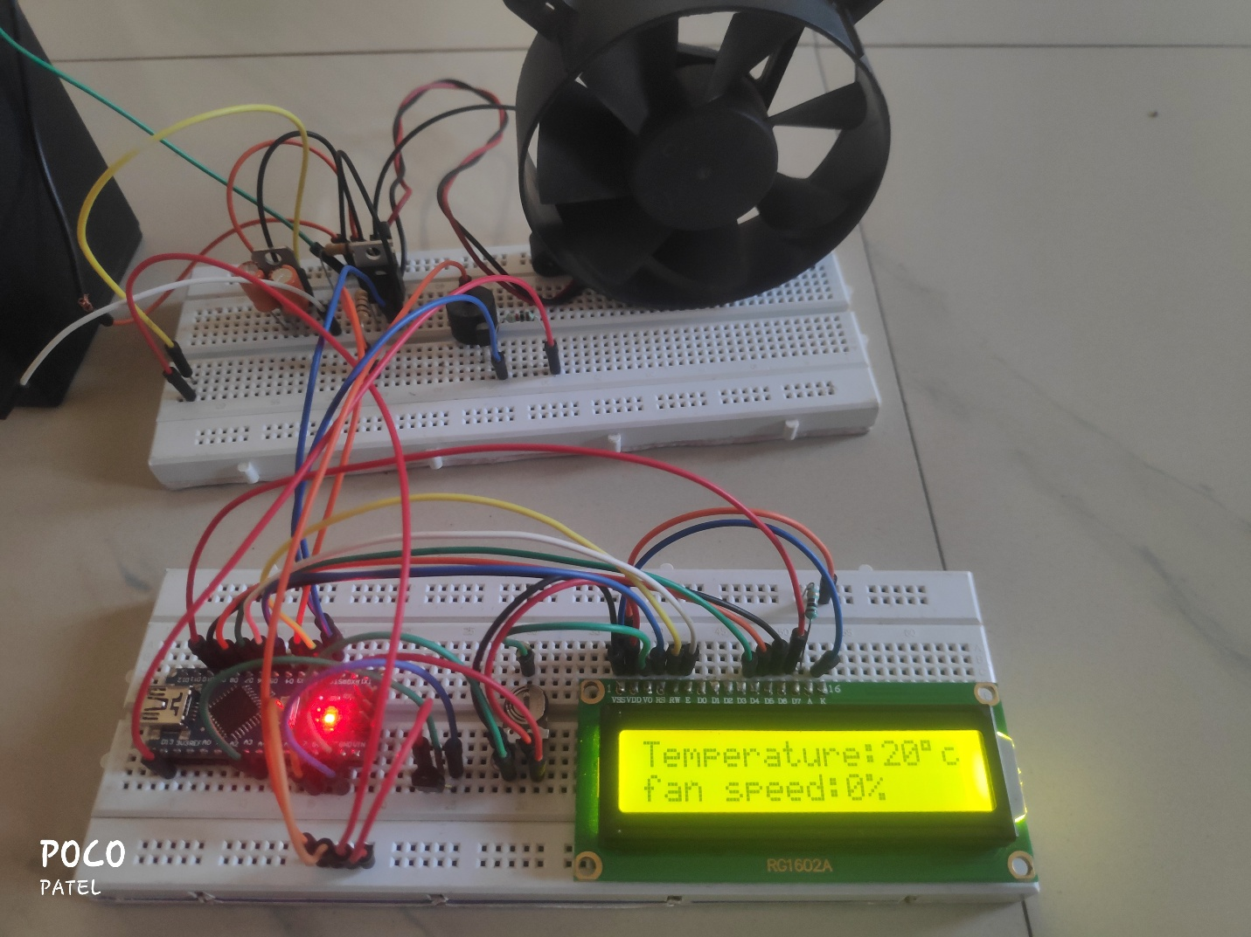
Picture-3
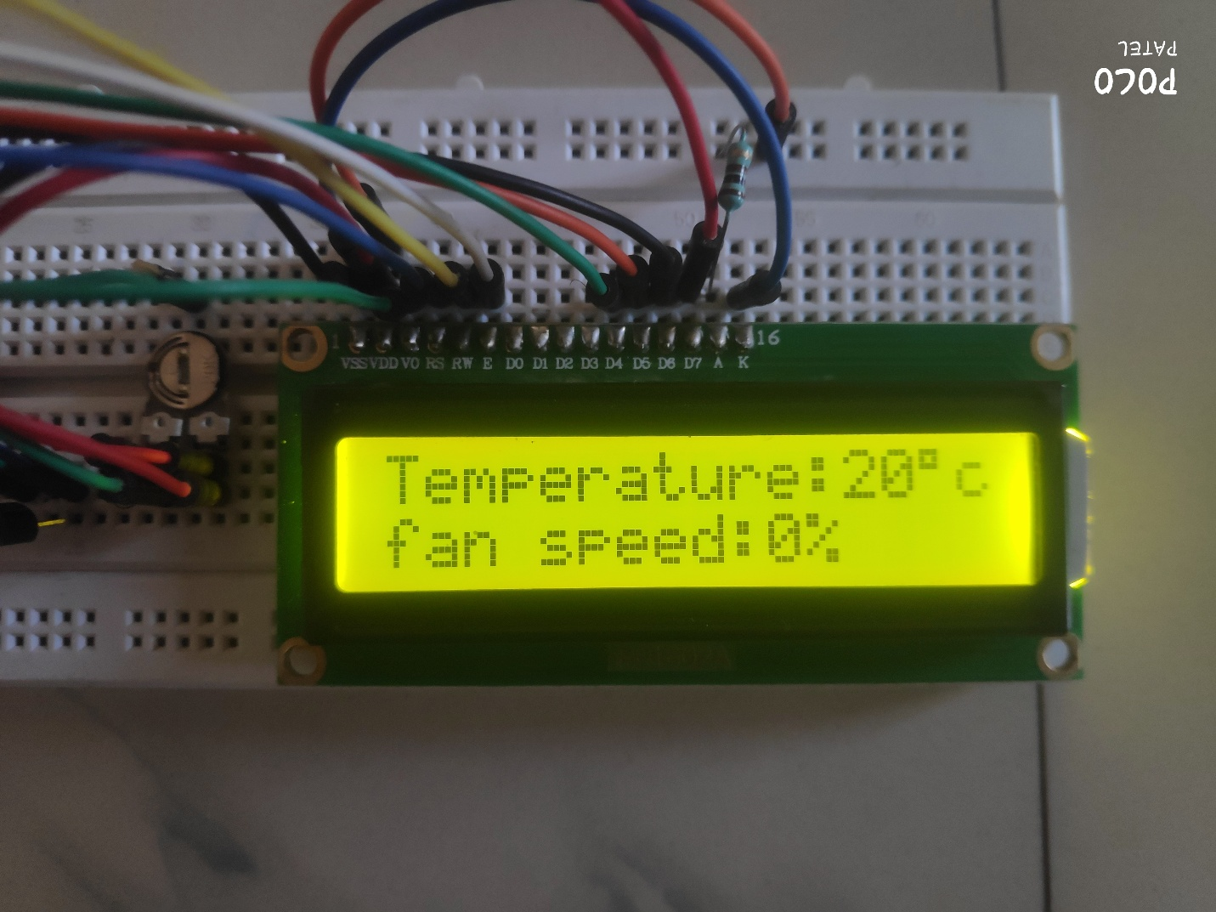
Picture-4
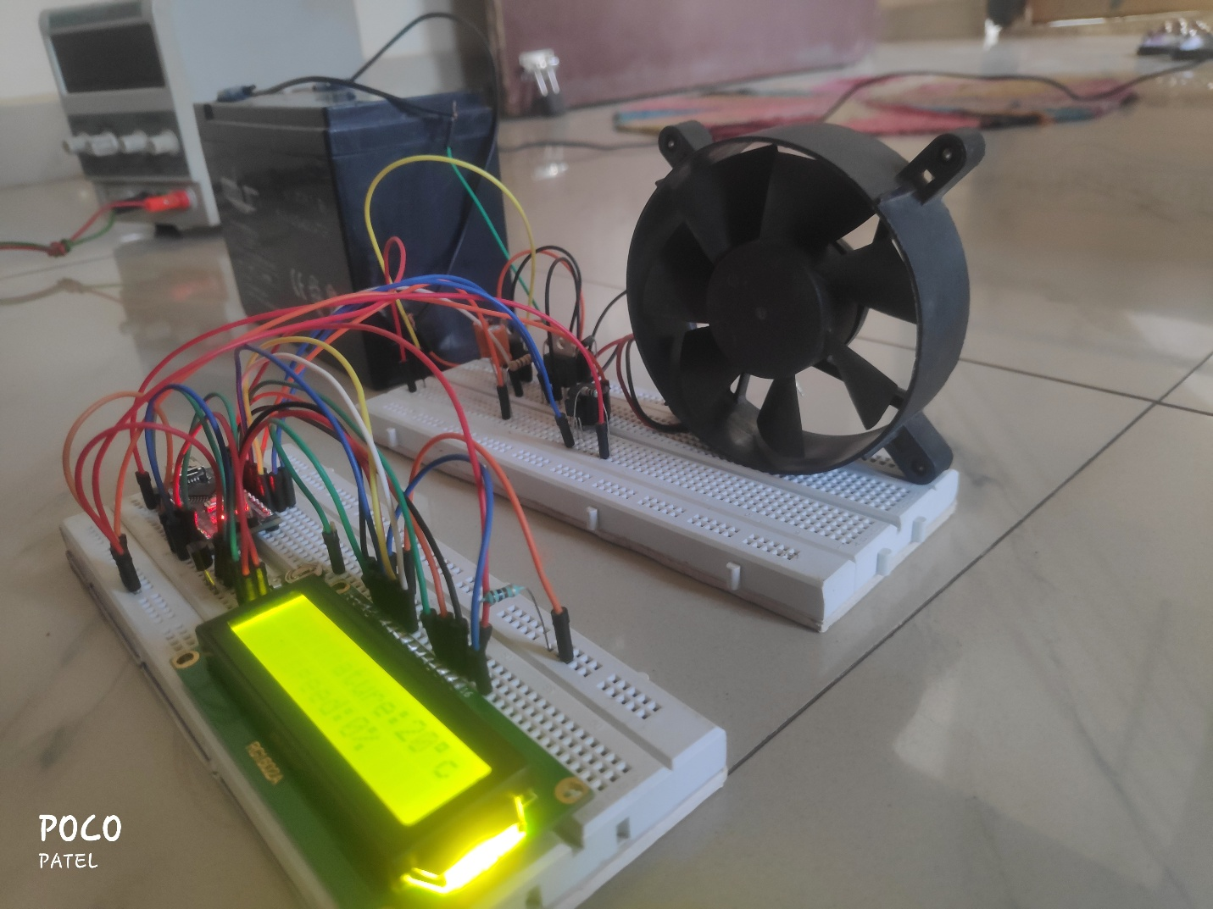
Picture-5
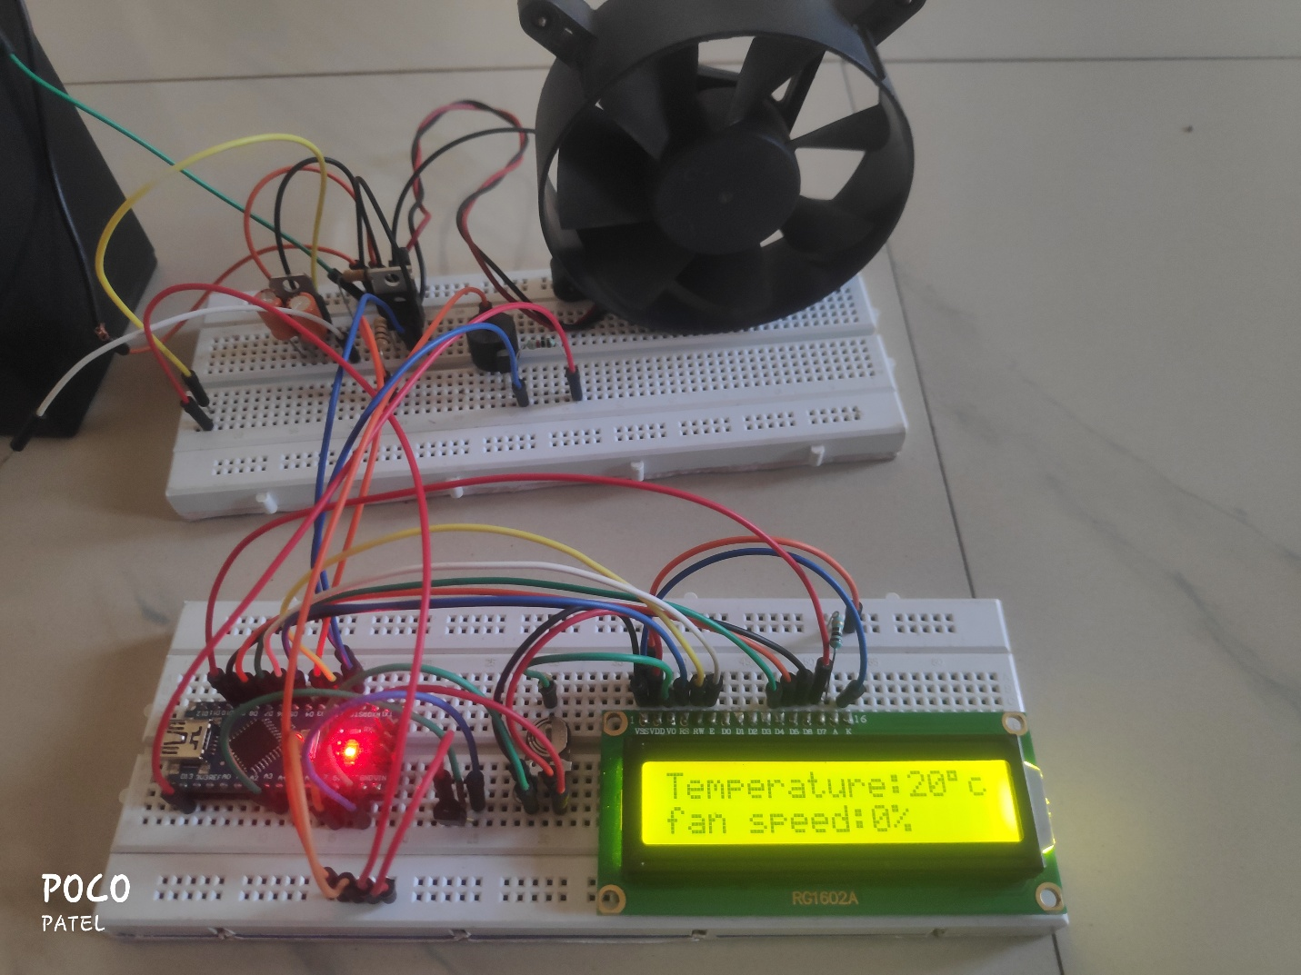
Picture-6
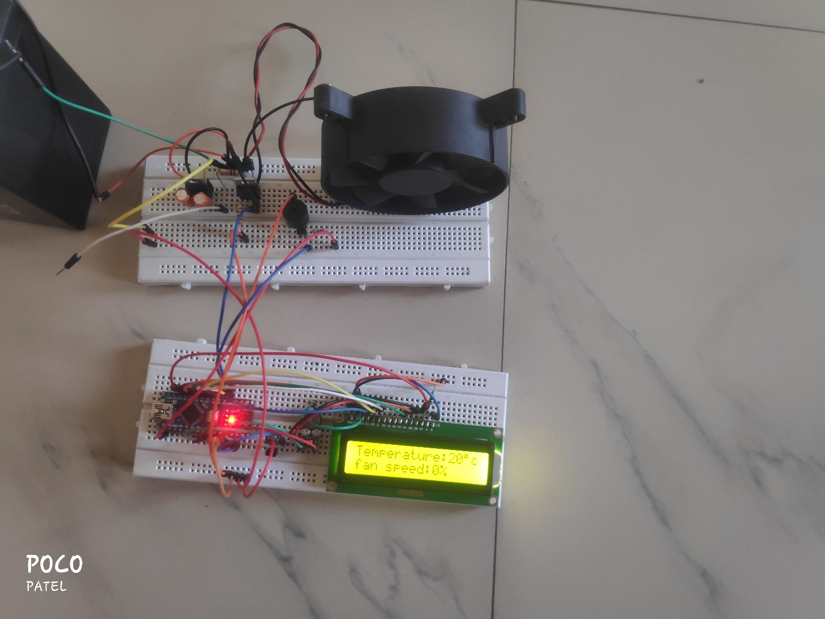
Picture-7
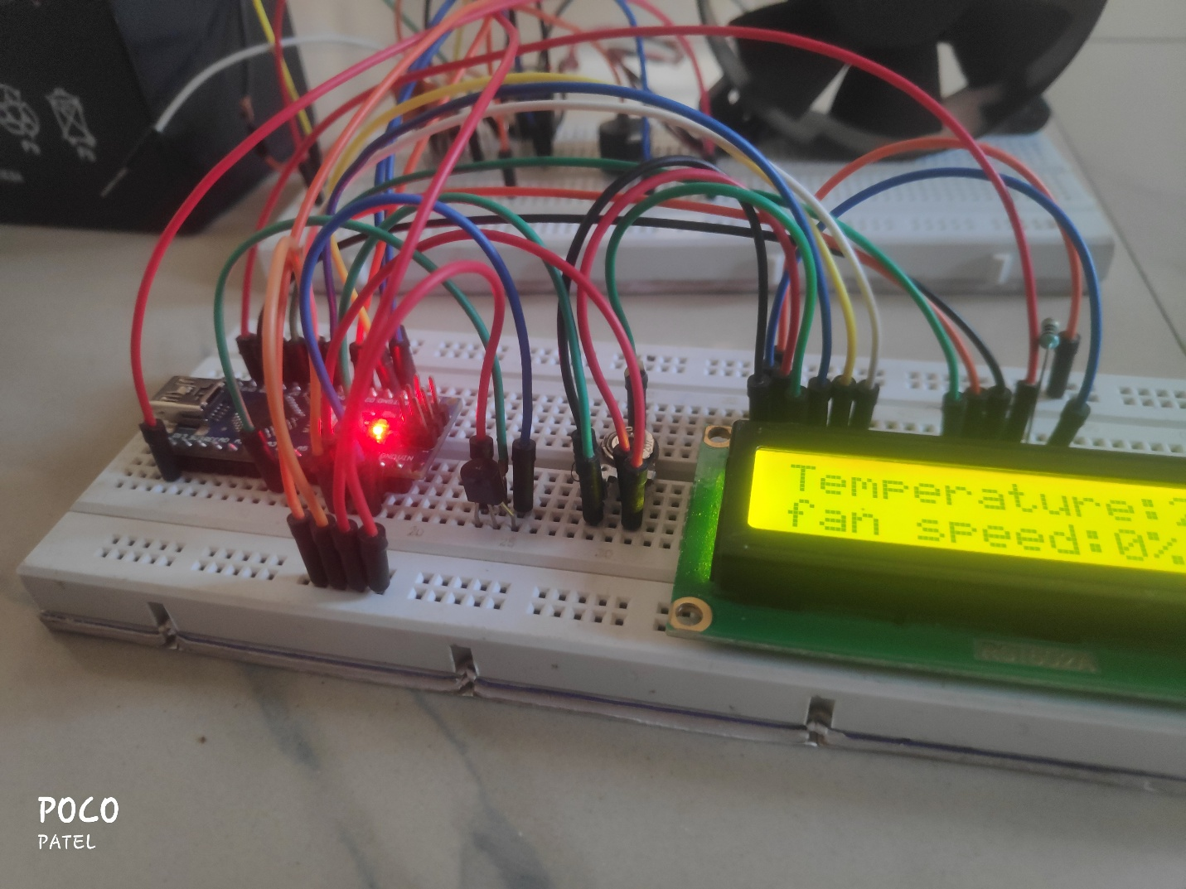
Picture-8
